**MUSIC FESTIVAL MANAGEMENT SYSTEM**

**ADHIAMBO IVY NOVAREEN ONYANGO**

**A Research project submitted to the School of Science, Engineering and Technology in partial fulfillment of the requirements of the reward of Diploma in Information Technology, Kabarak University.**

**November, 2025**

**COPYRIGHT**

**2025**

All rights reserved No part of this project may be produced, stored in any retrieval system or transmitted in any form or transmitted in any form or by any means, electronic, mechanical, prototyping and recording without prior written permission or the author or Kabarak University on that.

Sign: ……………………… Date…………………….

# DECLARATION AND APPROVAL

I, Adhiambo Ivynovareen Onyango, declare that this project entitled ‘Music Festival Management System’ is my original work and has not been presented elsewhere for academic credit. All sources of information used have been duly acknowledged.

Signed: …………………… Date ……………………

Student: Adhiambo Ivy Novareen

Reg No: DIT/N/2832/09/24

# RECOMMENDATION

This research proposal entitled Music Festival Management System by Adhiambo Ivy Novareen Onyango is presented to the School of Science Engineering and Technology of Kabarak University. I have reviewed this project and recommend it would be accepted in partial fulfillment of the requirements for the Diploma in Information Technology.

Signature……………………………. Date……………………………..

Mr. Elvine Saikwa,

School of Science Engineering and Technology,

Department of Computer Science and Information Technology,

Kabarak University.

# ACKNOWLEDGMENT

I sincerely thank my supervisor, Mr. Elvine Saikwa for his guidance, patience, and invaluable feedback throughout the development of this project. I also acknowledge my colleagues and the and the Kabarak University Department of Information Technology for their support and resources.

# DEDICATION

This project is dedicated to my parents for the greatest support they have offered throughout my studies, the guidance and the advice they have given me through my life and education. I also dedicate it to my classmates and friends for the assistance and the role they have played in my achievement academically.

# ABSTRACT

The Music Festival Management System is designed to modernize the registration and results publication process for music festivals. Traditionally, these processes are carried out manually, leading to inefficiencies, errors and time wastage. This project automates participant registration, class selection and results display. The system allows participants to register online, judges to input results digitally and users to view performance outcomes instantly. The system is built using PHP, MySQL, HTML, CSS and JavaScript, ensuring a reliable, scalable and user-friendly platform for both participants and administrators.

**Keywords*:*** *MFMS, Performance*

TABLE OF CONTENTS

DECLARATION AND APPROVAL iii

RECOMMENDATION iv

ACKNOWLEDGMENT 2

DEDICATION 3

ABSTRACT 4

LIST OF FIGURES 8

CHAPTER ONE 2

INTRODUCTION 2

1.0 Background of the Study 2

1.1 Problem Statement 3

1.2 Objective of the System 3

1.2.1 General Objective 3

1.1.2 Specific Objectives 3

1.3 Research Questions 4

1.4 Justification of the Study 4

1.5 Scope of the Study 4

1.6 Limitation of the Study 4

1.7 Definition of Terms 5

CHAPTER TWO 6

LITERATURE REVIEW 6

2.1 Introduction 6

2.2 Overview of Music Industry Management Systems 6

2.3 The Role of Content Management Systems (CMS) in Music Applications 6

2.4 Database Management in Music Systems 7

2.5 Web-Based Registration Systems 8

2.6 Result Management Systems 8

2.7 Related Works 8

2.8 Research Gap 9

2.9 Conceptual Framework 9

2.10 Summary 10

CHAPTER THREE 11

RESEARCH METHODOLOGY 11

3.0 Introduction 11

3.1 System Development Methodology 11

3.2 System Analysis Overview 12

3.3 Problem Definition 12

3.4 System Objectives 12

3.4.1 General Objective 12

3.4.2 Specific Objectives 12

3.5 System Requirements 13

3.5.1 Functional Requirements 13

3.5.2 Non-Functional Requirements 13

3.6 System Design Tools 13

3.7 Data Flow Diagrams (DFD) 14

3.7.1 Level 0: Context Diagram 14

3.7.2 Level 1: Data Flow Diagram 15

3.7.3 Level 2: Process Flow 16

3.8 Entity Relationship Diagram (ERD) 17

3.10 System Flowchart 18

3.11 Use Case Diagram 19

3.13 Summary 19

CHAPTER FOUR: 20

SYSTEM ANALYSIS, IMPLEMENTATION AND DESIGN 20

4.0 Introduction 20

4.1 System Design Overview 20

4.2 System Architecture Diagram 21

4.3 Database Design 21

4.3.1 Database Schema 21

4.3.2 Entity Relationship Diagram (ERD) 22

4.4 User Interface Design 23

4.4.1 Login Interface 23

4.4.2 Registration Interface 24

4.4.3 Admin Dashboard 25

4.4.4 Participant Registration Form 25

4.4.5 Results Page 26

4.5 System Implementation 26

4.5.1 Development Tools. 26

4.5.2 Coding Modules 27

4.6 Summary 27

CHAPTER FIVE: 28

CONCLUSION AND RECOMMENDATION 28

5.0 Introduction 28

5.1 Conclusion 28

5.2 Recommendations 28

REFERENCES 29

APPENDICES 30

Appendix A: Project Source Code Structure 30

Appendix B: MySQL Database Schema 31

Appendix C: User Interface Mockups 32

Appendix D: Test Cases and Results 33

Appendix E: Hardware and Software Requirements 34

Appendix F: User Manual Summary 34

# LIST OF FIGURES

Figure 1 Input Process Diagram 19

Figure 2 Development methodology 21

Figure 3 Context diagram 24

Figure 4 Data flow diagram 25

Figure 5 Process flow diagram 26

Figure 6 Entity relationship diagram 27

Figure 7 System flowchart 28

Figure 8 Use case diagram 29

Figure 9 System architecture diagram 31

Figure 10 ERD diagram 33

Figure 11 Login interface 34

Figure 12 Registration interface 35

Figure 13 Admin dashboard 36

**LIST OF ABBREVIATIONS**

MFMS- Music Festival Management System

CSS- Cascading Style Sheets

DBMS- Database Management System

HTML-Hyper Text Markup Language

DIT- Diploma in Information Technology

PHP-Hypertext Preprocessor

SDLC-Software Development Life Cycle

# CHAPTER ONE

# INTRODUCTION

## 1.0 Background of the Study

Music festivals play an important role in promoting cultural expression, talent development, and social interaction within learning institutions. In Kenya, tertiary institutions such as vocational training centres, teachers’ colleges, technical institutes, national polytechnics, and universities actively participate in annual music festivals. These festivals involve numerous performance classes, set pieces, and evaluation criteria that require proper coordination and accurate record-keeping. Traditionally, registration and results management for such festivals have been handled manually using paper forms, handwritten registers, and spreadsheets. While these methods have been used for many years, they present several challenges including data loss, delays in processing results, difficulty in retrieving records, and inconsistency in scoring across different levels of competition.

As the number of participating institutions continues to grow, the manual approach becomes increasingly inefficient and prone to errors. For example, institutions present multiple performances under different classes such as 111M, 112M, 113M, 121M, and 113P, each associated with unique set pieces and composers. Managing this information manually creates logistical challenges for organizers, administrators, and adjudicators. Furthermore, the lack of a centralized system makes it difficult to track school performances, update class details, or generate accurate results in real time.

With advancements in information technology, many organizations are transitioning to digital systems that automate routine processes and improve data accuracy. In this context, a Music Festival Registration and Results Management System become essential. Such a system enables participating schools to register online, upload performance entries, and view updated schedules. It also allows administrators to manage class categories, assign judges, record scores, and publish results instantly. The use of a web-based system enhances transparency, reduces paperwork, and speeds up decision-making.

This project aims to design and develop a system that addresses these challenges by providing a reliable and efficient platform for festival registration and results processing. Using technologies such as PHP, MySQL, HTML, CSS, and JavaScript, the system ensures secure data handling, structured workflows, and user-friendly interfaces for both administrators and schools. By digitalizing the entire festival process, the proposed system not only improves operational efficiency but also supports accurate reporting, accountability, and future scalability. Ultimately, the system contributes to the modernization of festival management within tertiary institutions and aligns with current trends in digital transformation within the education and entertainment sectors.

## Problem Statement

The annual music festivals for tertiary institutions rely heavily on manual processes for registration, management of performance entries, adjudication, and publication of results. Participating schools often submit their entries through handwritten forms or spreadsheets, leading to frequent errors, misplaced data, and delays in verifying registration details. During the festivals, adjudicators manually record scores, which introduces inconsistencies, reduces accuracy, and complicates the compilation of final results. Additionally, accessing festival information such as class categories, performance schedules, and results is difficult for institutions and stakeholders because the data is dispersed, paper-based, or inconsistently documented.

The lack of a centralized digital platform results in inefficiencies, long processing times, difficulty in retrieving past festival records, and minimal transparency in results management. As the number of participating institutions continues to grow and the volume of performance entries increases, the existing manual system is no longer sustainable. Therefore, there is a need for a streamlined, automated, and secure Music Festival Registration and Results Management System that can manage registrations, store festival data, facilitate adjudication, and provide instant, accurate results to all stakeholders.

## Objective of the System

### 1.2.1 General Objective

To develop a web-based system for managing music festival registration and results publication.

### 1.1.2 Specific Objectives

1. To enable online registration for participants.
2. To provide an interface for judge to upload results.
3. To allow users to view festival results online.

## Research Questions

1. How can registration process for music festival participants be automated to reduce errors and improve efficiency?
2. How can results recording and tabulation be improved through the use of an online system?
3. What mechanism can be implemented to ensure secure storage and easy retrieval of festival data such as classes, performances, judges and scores
4. How can the system improve transparency, accuracy and accessibility of festival results?

## Justification of the Study

This study is justified by the need to replace the slow, error-prone manual music festival registration process with a more efficient digital system. Automating registration and results management will reduce administrative workload and eliminate data loss associated with paper-based methods. The system will enhance accuracy in adjudication, improve transparency, and provide instant access to results for participating institutions. Additionally, it ensures secure storage of festival records for future reference and analysis. Overall, the system will modernize festival operations and support better coordination among administrators, adjudicators, and schools.

## Scope of the Study

This study focuses on designing and developing an online system for music festival registration, class selection, adjudication, and results display for tertiary institutions. It covers user management, online performance entry, database storage, and automated results generation. The system will support administrators, judges, and participating schools. It is limited to digital registration and results retrieval, excluding physical event logistics. The study also includes UI/UX design, database implementation, and system testing within a controlled environment.

## Limitation of the Study

1. I didn’t have my personal computer, this became the biggest challenge.
2. Availability of internet became an issue due to lack of enough funds.
3. Time management was another factor that was a little difficult to curb.

## Definition of Terms

1. Registration: The process of enrolling participants for specific festival categories.
2. Results management: The process of recording, storing, and displaying of competition results.
3. System: A coordinated set of components designed to perform a specific function.

# CHAPTER TWO

# LITERATURE REVIEW

## 2.1 Introduction

This chapter provides a detailed review of existing literature relevant to the development of Music Industry Management System. It explores concept related to content management system, online event registration, database design using MySQL and system usability. The review also examines previous related studies, identifies research gaps and establishes the theoretical and conceptual framework that supports the project.

## 2.2 Overview of Music Industry Management Systems

Music management systems are digital platforms designed to streamline processes such as artist registration, event scheduling, performance tracking, music uploads and results management.

These systems integrate various functionalities to improve communication and coordination between artists, administrators and audiences.

According to contemporary studies, the digital transformation of music management has revolutionized how festivals, concerts and music competitions are organized. Systems such as Spotify for Artists, SoundCloud Manager and Bandcamphave demonstrated the importance of digital control in data-driven management of musical activities.

However, many local music organizations still rely on manual registration and results dissemination, leading to inefficiencies that modern web-based solutions can solve.

## 2.3 The Role of Content Management Systems (CMS) in Music Applications

A Content Management System is a software framework that enables users to create, modify and manage digital content without deep programming knowledge. In the context of music management, a CMS allows administrators to publish announcements, manage user profiles, store performances, and display competition results dynamically.

Modern CMSs such as WordPress, Joomla and Drupal are built on PHP and MySQL, making them highly adaptable for web-based music platforms.

They allow administrators to:

1. manage multimedia files (audio, video, and images).
2. Control user accounts and permissions.
3. Publish and update competition results dynamically.

Integrating CMS principles into a music management system helps enhance usability, maintainability and scalability. As noted by Reynolds (2021), who emphasized that CMS-driven systems improve collaboration and reduce development time by separating content from presentation.

## 2.4 Database Management in Music Systems

A **Database Management System (DBMS)** such as MySQL provide an organized way to store, retrieve and manipulate data. It ensures data integrity and supports relational structures through primary and foreign key relationships.

In this project, MySQL is used to store user details, class information, registration records and results.

The use of relational database ensures that:

1. Data redundancy is minimized.
2. Relationships between entities (users, classes, results) are maintained.
3. Queries and reports can be generated efficiently.

According to Codd (1970), the relational database model provides a powerful framework for structuring data through normalization and key constraints, making it ideal for modern web systems.

## 2.5 Web-Based Registration Systems

Web-based registration system allows users to register, manage and track participation online. They eliminate geographical and temporal limitations, providing convenience to users and administrators. In music festivals, online registration simplifies submission of performance details and automatic storage in the database.

Several studies have explored digital registration:

1. **Mwangi (2020)** developed an *Online Student Registration System* that reduced manual errors and enhanced data accuracy.
2. **Akinyi (2021)** proposed an *Event Management Web System* that integrated ticketing, scheduling and reporting functionalities.

Both studies emphasize that online registration systems must include user authentication, responsive design and secure data handling which are also features incorporated in this project.

## 2.6 Result Management Systems

It automates the process of recording, storing and publishing result. It ensures transparency and eliminates bias by providing digital records accessible to authorized users.

In the music industry, result management systems can track individual performance scores, calculate rankings, and display outcomes online. According to Oluoch and Kiptoo (2022),automated results reduce administrative workload by up to 60% and improve trust among participants through timely and accurate publication.

The proposed Music Industry Management System integrates result management with user access roles allowing only judges and administrators to input results while participants can only view their scores.

## 2.7 Related Works

Numerous systems have been designed to automate different aspects of creative event management:

**Table 1 Related systems**.

|  |  |  |  |
| --- | --- | --- | --- |
| **Researcher/Year** | **System Developed** | **Features** | **Limitations** |
| **Kimani (2019** | Online Music Festival Management | Registration, scheduling | No online results display |
| **Mwangi (2020)** | Student Registration Portal | Form validation, email alerts | No event-oriented |
| **Akinyi (2021)** | Event Ticketing Portal | Online booking, dashboard | No judge module |
| **Proposed System (2025)** | Music Industry Management System | Registration, results judge control, CMS design | Comprehensive and scalable |

The table above highlights that existing systems often lack full integration of both registration and results management. The proposed system bridges that gap through an all-in-one platform.

## 2.8 Research Gap

Most existing systems address isolated components such as registration or result publication but rarely integrate both.

The proposed system fills this gap by combining user registration, event management and results display within one secure and interactive web platform.8

## 2.9 Conceptual Framework

It illustrates the logical flow between the main entities of the system.

**Inputs:** User data, event details, performance submissions.

**Processes:** Registration validation, result computation, content management.

**Outputs:** Published results, event summaries, user notifications.

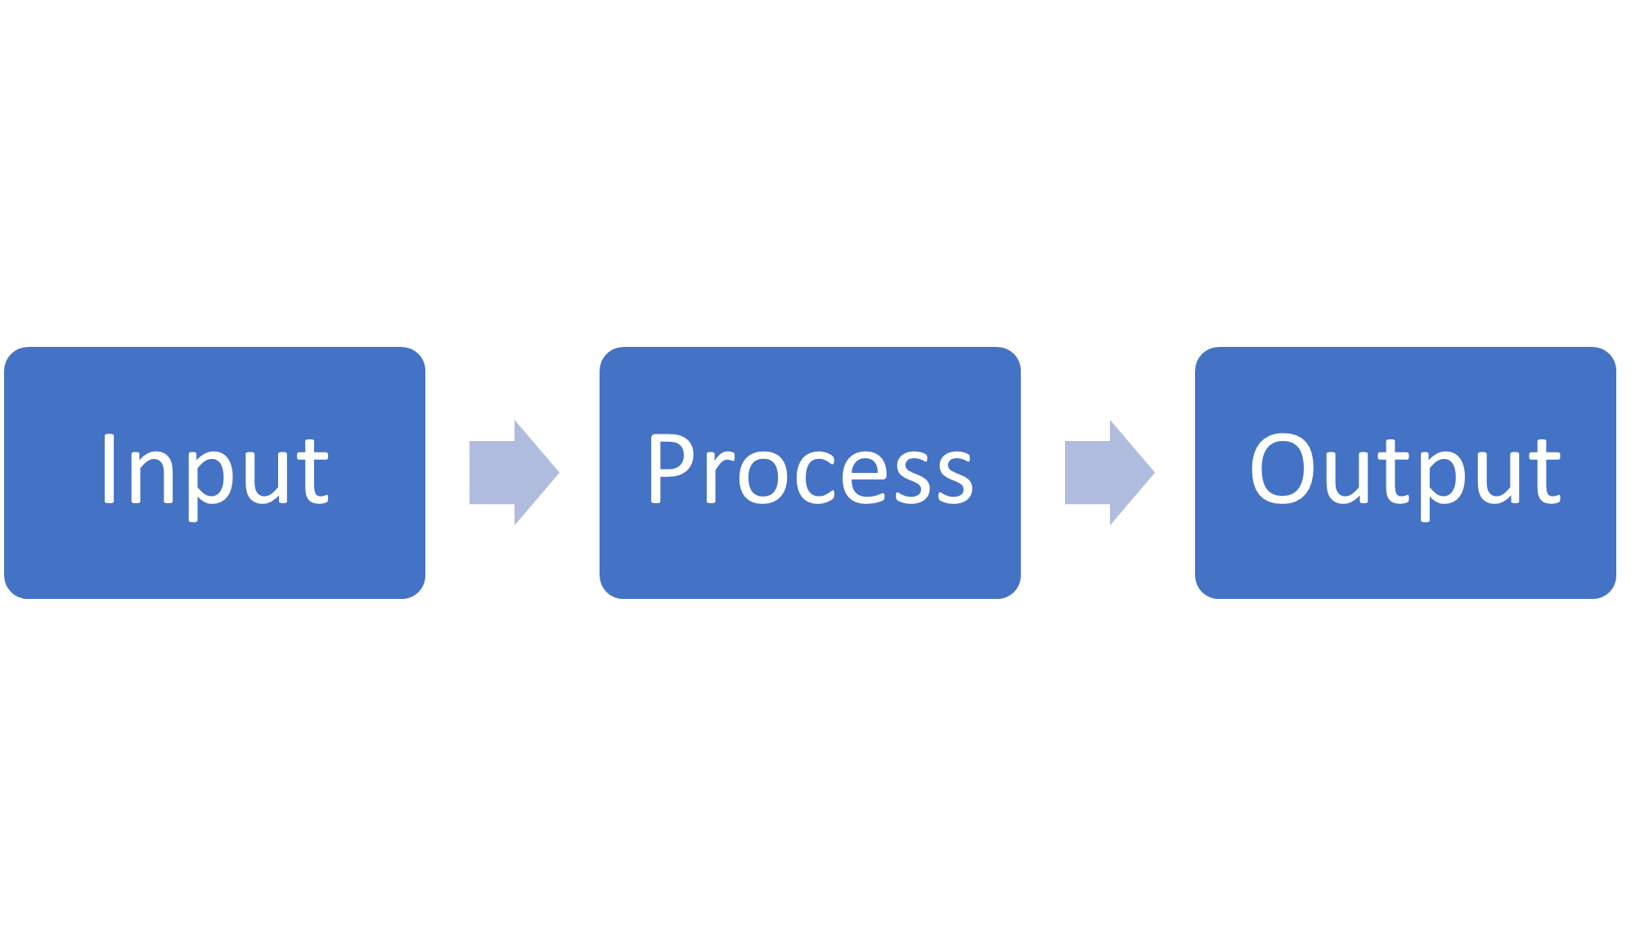

**Figure 1:** Input Process Diagram

## 2.10 Summary

This chapter reviewed existing literature on music industry automation, content management systems, database management and related terminologies. It identified gaps in existing solutions and established theoretical foundations for developing an integrated system that supports registration, performance tracking and results dissemination through a CMS-driven MySQL application.

# CHAPTER THREE

# RESEARCH METHODOLOGY

## 3.0 Introduction

This chapter discusses the analysis and design of the proposed Music Industry Management System, focusing on system requirements, design methodology, database architecture, and interface mockups.

The goal is to transform user needs into a structured system design that enables efficient online registration, class management, and results publication for music events.

## System Development Methodology

My project, Music Festival Management System uses the waterfall software development model.

I first began with the proposal ( requirement analysis) then created system diagrams ( DFD, ERD, UI Mockups), created the database, began writing the code, testing and deployment and finally by document writing.

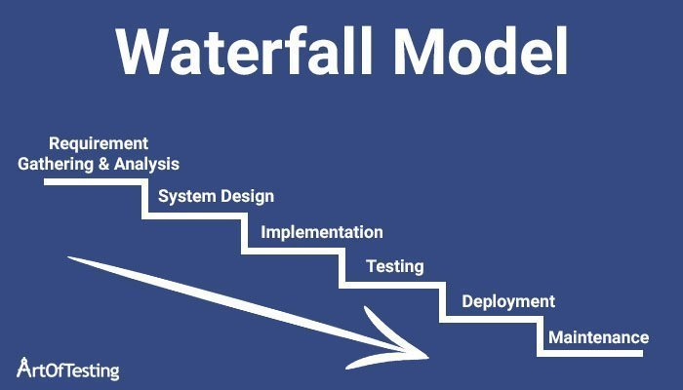

**Figure 2**: Development methodology

## 3.2 System Analysis Overview

The current manual registration and result dissemination process in the music department leads to inefficiencies, errors, and data loss. The proposed system aims to automate these processes by providing:

1. Online registration for participants.
2. Centralized class and performance management.
3. Online results display.
4. User access based on roles (Admin, Participant, Judge).

## 3.3 Problem Definition

The main problem addressed by this project is the lack of an integrated digital platform for managing music festival registrations and results. Currently:

1. Data collection is manual, slow, and prone to errors.
2. Results are displayed physically, limiting accessibility.
3. Event coordination is time-consuming and poorly organized.

## 3.4 System Objectives

### 3.4.1 General Objective

To design and implement a web-based Music Industry Management System that automates event registration and result management using MySQL and PHP technologies.

### 3.4.2 Specific Objectives

1. To allow users to register and select performance classes online.
2. To store and manage participant data efficiently using a relational database.
3. To enable judges and admins to upload and publish results digitally.
4. To ensure data integrity, security, and role-based access control.
5. To provide an intuitive and user-friendly interface for all users.

## 3.5 System Requirements

### 3.5.1 Functional Requirements

1. User registration and login authentication.
2. Admin control over user accounts and classes.
3. Online registration for music performances.
4. Judge result entry and validation.
5. Public display of results.
6. Report generation and data export.

### 3.5.2 Non-Functional Requirements

1. System should be web-based and responsive.
2. Data should be encrypted and securely stored.
3. System should handle concurrent users efficiently.
4. Interface should be intuitive with purple-white theme.

## 3.6 System Design Tools

The design process employed tools such as:

1. Draw.io for DFDs and ERD diagrams.
2. Figma for UI mockups.
3. MySQL Workbench for schema visualization.

## 3.7 Data Flow Diagrams (DFD)

### 3.7.1 Level 0: Context Diagram

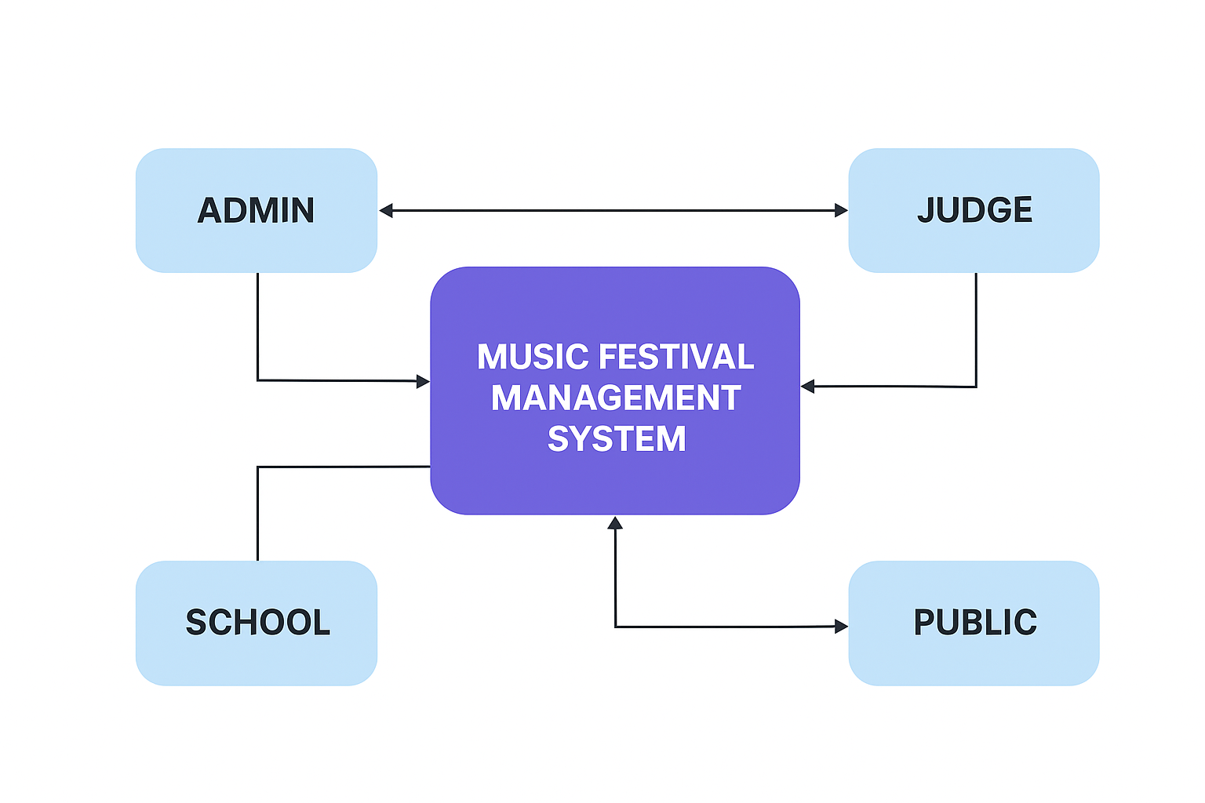

**Figure 3:** Context diagram

Shows the system at the center and the external entities that interact with it.

1. ADMIN- manages users, classes, approvals and results
2. SCHOOL- registers for performances, views results
3. JUDGE- records scores and comments
4. PUBLIC- views published results
5. MFMS- the main system they all interact with.

### 3.7.2 Level 1: Data Flow Diagram

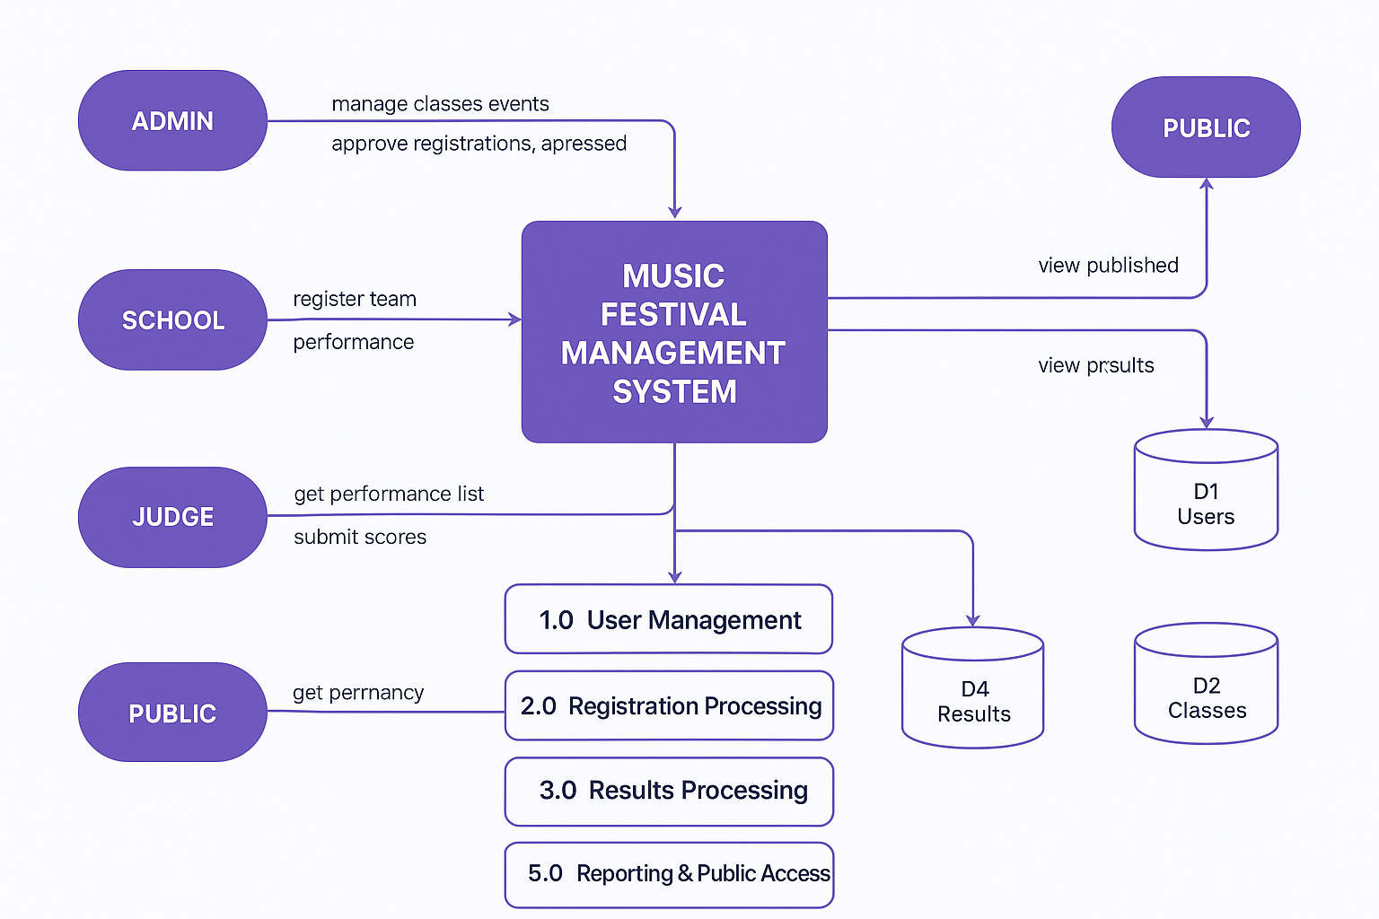

**Figure 4**: Data flow diagram

User Management- registers users, authenticate and manage roles (admin, school, judge, public profiles)

Registration Processing- receive and validate team registration, store registration records, change status (pending-approved/rejected)

Results Processing- (judge submit scores-store results-admin verifies and publishes)

Reporting and Public Access- generate reports, display published results to public and schools.

### 3.7.3 Level 2: Process Flow

This level details how registration data is validated, stored in the MySQL database, and later retrieved for report generation or result publishing.

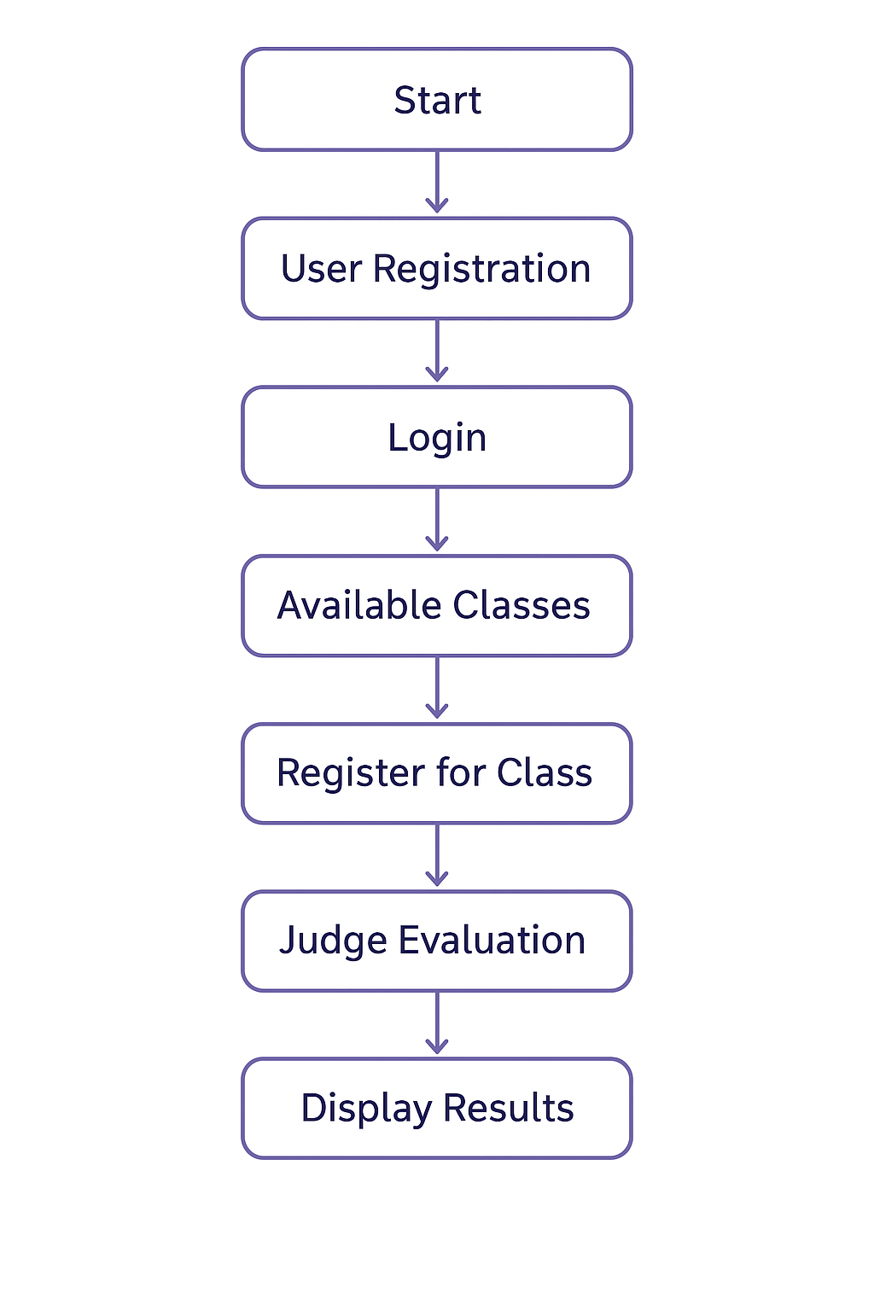

**Figure 5**: Process flow diagram

## 3.8 Entity Relationship Diagram (ERD)

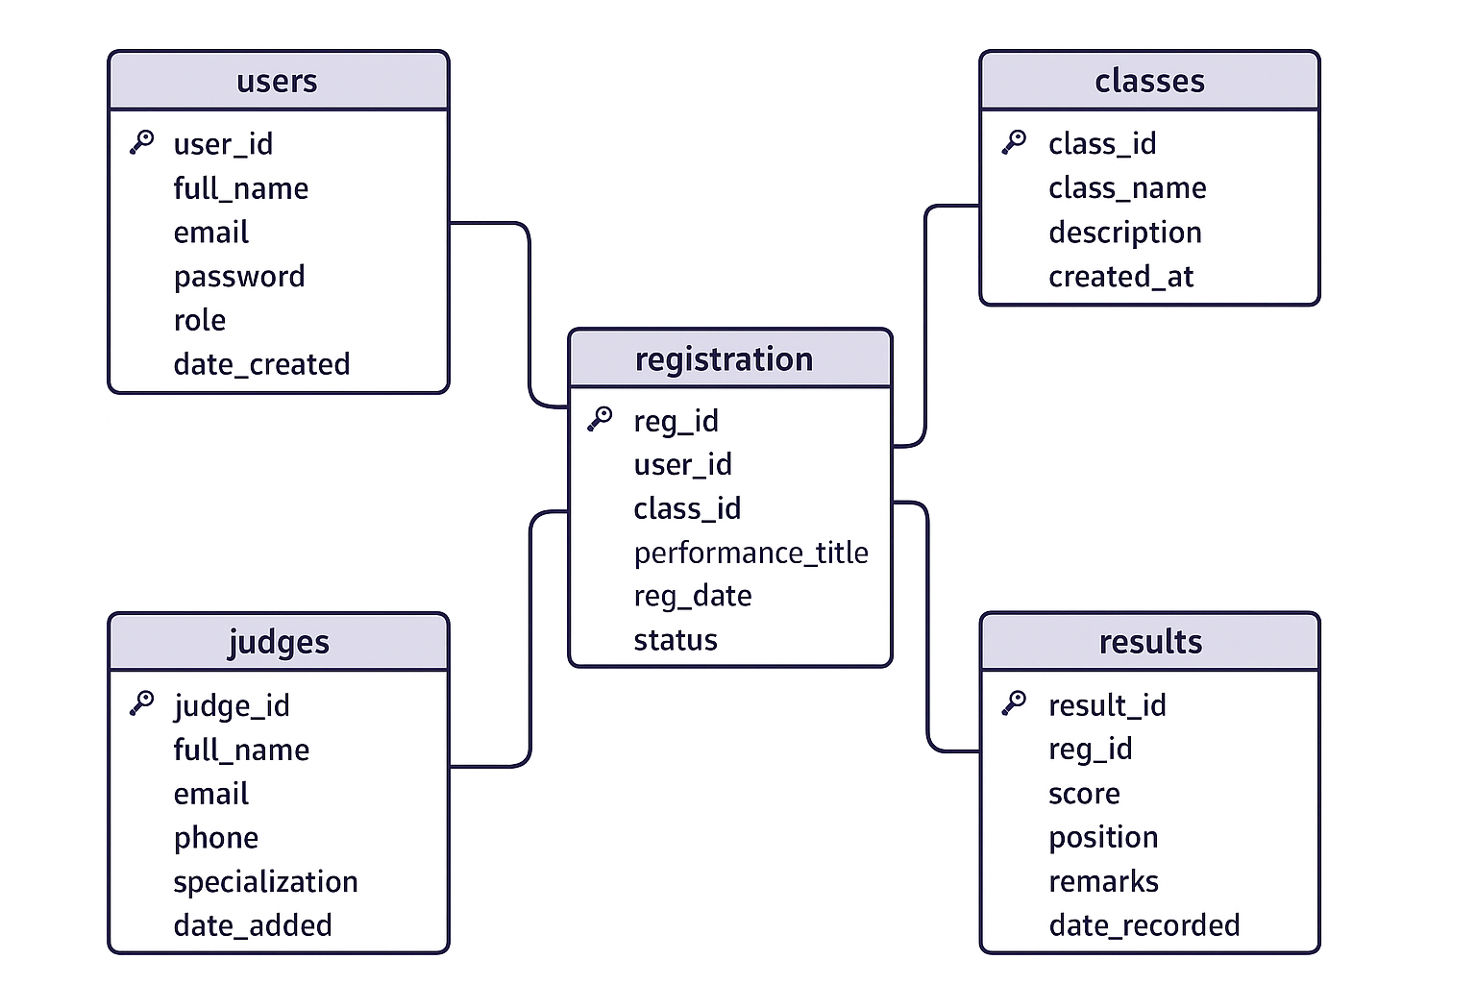

**Figure 6:**Entity relationship diagram

Relationships:

1. One user can register for many classes (One-to-Many).
2. Each class can have multiple registrations.
3. Each registration can have multiple results.
4. Each result is linked to a specific judge.

## 3.10 System Flowchart

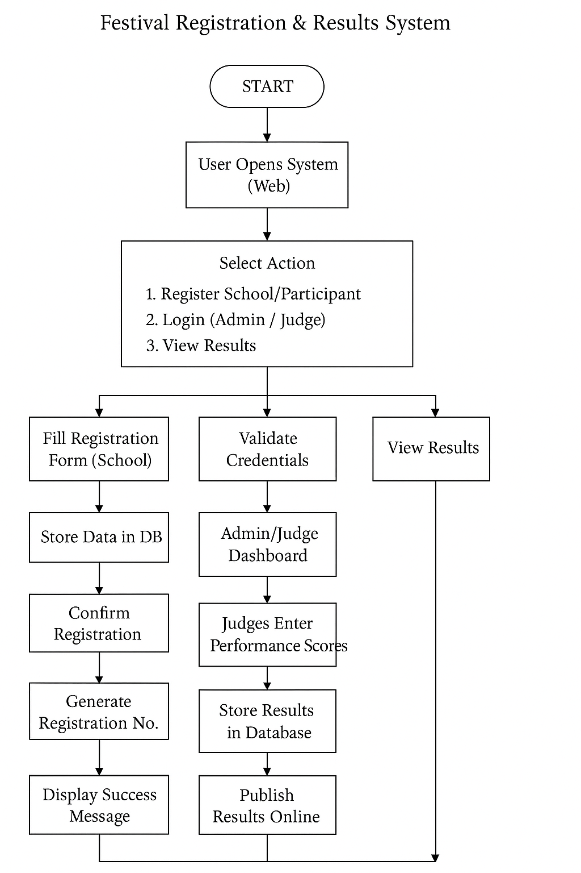

**Figure 7**: System flowchart

## 3.11 Use Case Diagram

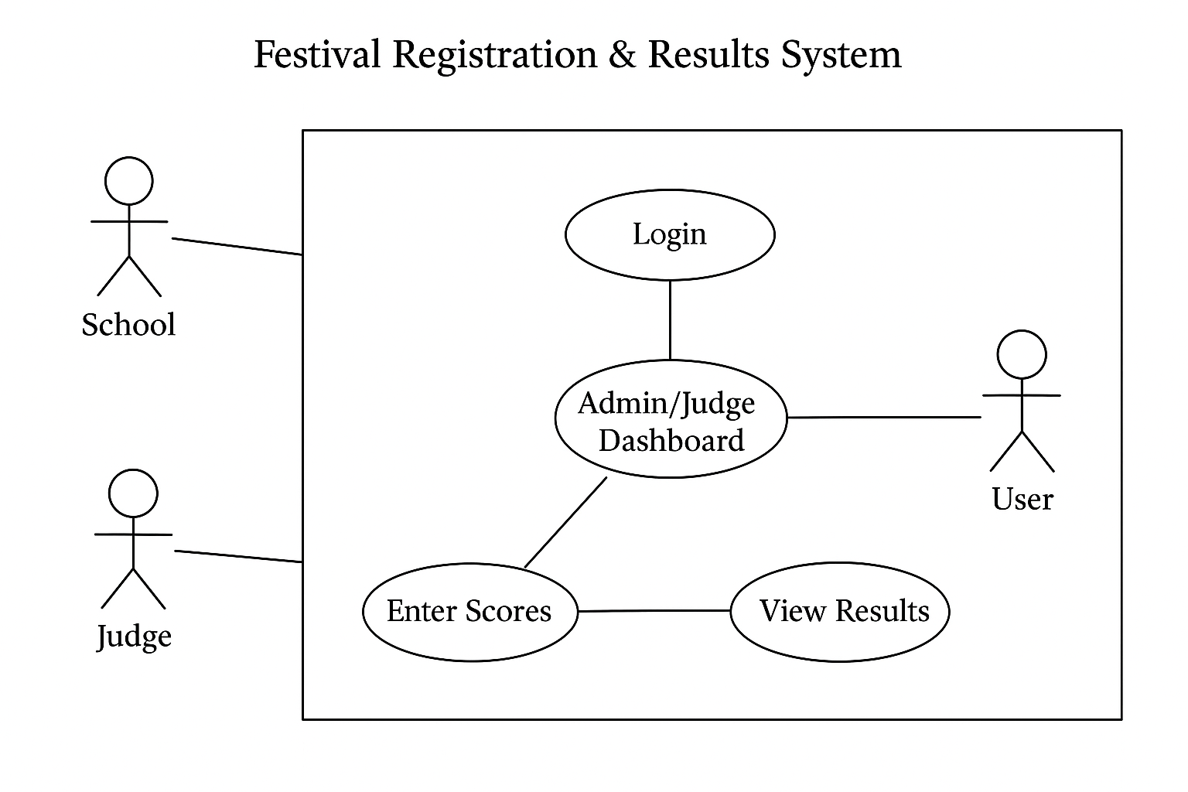

**Figure 8**: Use case diagram

## 3.13 Summary

The system analysis and design chapter has outlined the structure of the Music Industry Management System. It provides a detailed understanding of how data moves within the system, how users interact with it, and how information is stored and retrieved using MySQL. The next chapter discusses System Implementation, covering coding, testing, and integration

# CHAPTER FOUR:

# SYSTEM ANALYSIS, IMPLEMENTATION AND DESIGN

## 4.0 Introduction

This chapter presents the system design and implementation process for the Music Industry Management System. It outlines the design methodologies used, database schema, system architecture, and user interface layouts. The design phase transforms the system requirements identified in Chapter Three into a structured and detailed blueprint that guides the actual development and coding process. This ensures that the system meets user requirements and operates efficiently.

## 4.1 System Design Overview

System design is the bridge between the problem definition and the system solution. In this project, both conceptual and logical designs were used to model how different system components interact.

The Music Industry Management System was designed using a three-tier architecture consisting of:

1. **Presentation Layer**: The front-end web interface where users (admins, judges, and participants) interact.

2. **Application Layer**: The PHP logic that processes requests, manages sessions, and validates user input.

3**. Database Layer**: The MySQL database that stores information on users, registrations, judges, classes, and results

## 4.2 System Architecture Diagram

The architecture shows how data flows between users, the web application, and the database.

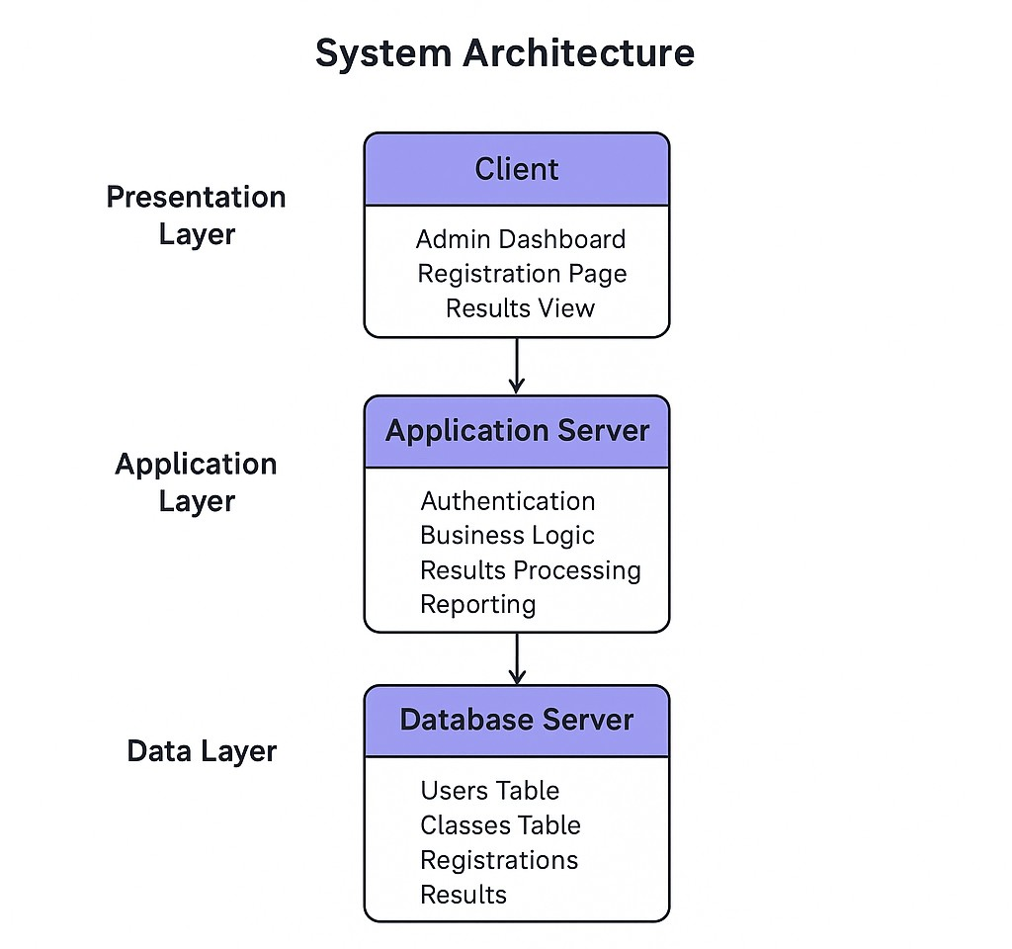

**Figure 9**: System architecture diagram

## 4.3 Database Design

The database for the system was implemented using MySQL. The design ensures data consistency, normalization, and referential integrity.

### 4.3.1 Database Schema

The schema consists of five main tables:

**Table 2. Database schema.**

|  |  |
| --- | --- |
| Table Name | Description |
| Users | Stores details of participants, judges and administrators |
| Classes | Contains information about performance categories and events |
| Registration | Links users to classes and records performance titles |
| Results | Stores judges’ evaluations, scores and positions |
| Judges | Contains information about judges and their specialization. |

### 4.3.2 Entity Relationship Diagram (ERD)

The ERD below illustrates how the database entities relate to each other.

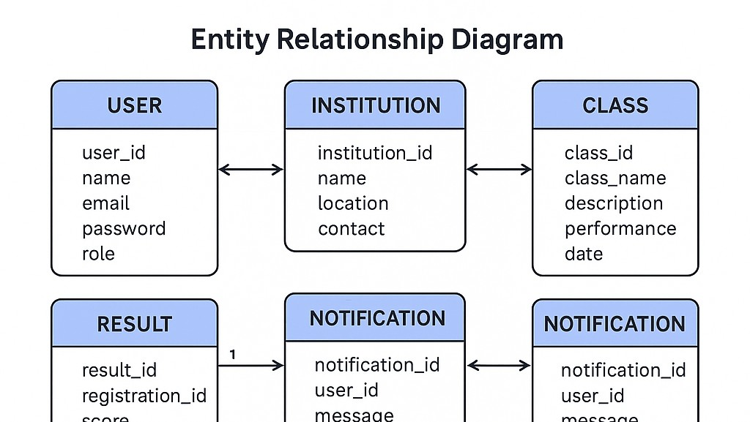

**Figure 10**: ERD diagram

Relationships:

1. One user can register for many classes (One-to-Many).
2. Each class can have multiple registrations.
3. Each registration can have multiple results.
4. Each result is linked to a specific judge.

## 4.4 User Interface Design

The UI design was developed with user-friendliness, simplicity, and accessibility in mind. The interface uses purple and white tones to provide a modern and professional look consistent with the branding of music industry applications.

### 4.4.1 Login Interface

-Provides fields for email and password.

-Includes user role detection (admin, participant, judge).

-Displays error messages for invalid logins.



**Figure 11**: Login interface

### 4.4.2 Registration Interface

Allows participants to sign up and register for specific classes.

Includes input validation and database linkage.



**Figure 12**: Registration interface

### 4.4.3 Admin Dashboard

Enables administrators to manage users, classes, and event results.

Displays summary statistics and graphical insights.

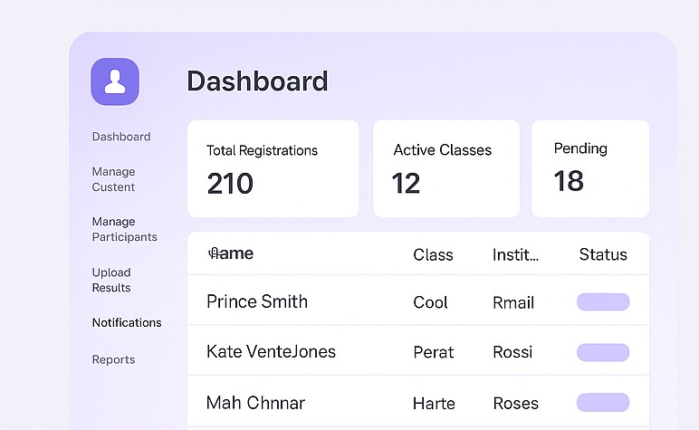

**Figure 13**: Admin dashboard

### 4.4.4 Participant Registration Form

Allows users to select classes and submit performance results.



**Figure 14: Participant form**

### 4.4.5 Results Page

Publicly accessible results display with filtering by class or participant.

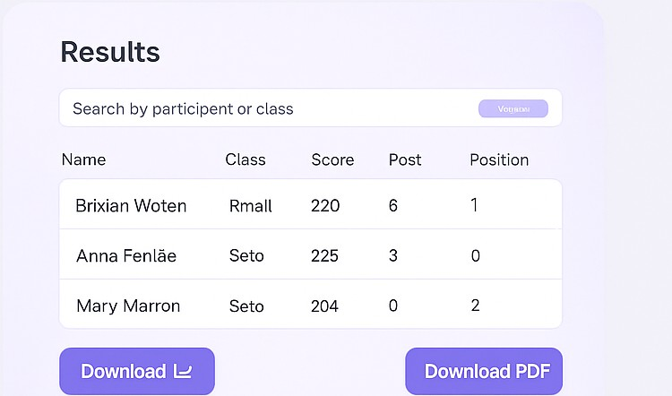

**Figure 15: Results page**

## 4.5 System Implementation

The implementation involved translating the system design into executable code. The back-end was developed using PHP for server-side processing, and the front-end used HTML, CSS, and JavaScript for presentation.

### 4.5.1 Development Tools.

**Table 3. Database tools.**

|  |  |
| --- | --- |
| Tools | Purpose |
| XAMPP | Local development environment for Apache, MySQL, PHP |
| VS Code | Integrated development environment for writing code |
| phpMyAdmin | Database management tool for MySQL |
| Figma | Used to create UI mockups |

### 4.5.2 Coding Modules

**Table 4:Coding Modules**

|  |  |
| --- | --- |
| Register.php | Handles user registration |
| Login.php | Manages user authentication |
| Admin dashboard.php | Displays admin operations |
| Judge portal.php | Allows judges to enter scores |
| Results.php | Displays competition outcomes |

## 4.6 Summary

This chapter detailed the design and implementation of the Music Industry Management System. It discussed system architecture, database schema, user interfaces, and the implementation process using PHP and MySQL. The design ensures that the system is robust, user-friendly, and scalable for future enhancements.

# CHAPTER FIVE:

# CONCLUSION AND RECOMMENDATION

## 5.0 Introduction

This chapter presents the testing, evaluation, and conclusion of the Music Industry Management System. It describes the approaches used to test the functionality, performance, and usability of the system. It also includes a discussion of system evaluation results, challenges encountered, and recommendations for future improvement. The chapter concludes with a summary of how the objectives outlined in Chapter One were achieved.

## 5.1 Conclusion

The Music Industry Management System successfully meets its primary objectives which is : to automate event registration, streamline class management, and digitalize judging results. The system provides an efficient platform that enhances transparency, saves time, and promotes professionalism within the music industry.

By applying software engineering principles, relational database management, and user-centered design, the project demonstrates how modern IT solutions can revolutionize the creative arts sector. Future improvements and scalability options make it a viable commercial product for music festivals, talent shows, and performance academies.

## 5.2 Recommendations

To further improve the system, the following are recommended:

1. **Online Payment Integration** – For registration fees.
2. **Mobile Application Version** – For better accessibility.
3. **Reporting Module** – Generate PDF or Excel reports for results.
4. **Cloud Deployment** – Host on a live web server for nationwide access**.**
5. **AI-Assisted Judging** – Future versions could incorporate AI-based performance evaluation.

# REFERENCES

Adewale, T. (2022). *Design and Implementation of Online Music Competition Management System*. International Journal of Computer Applications, 180(5), 45–53.

Akintunde, J. (2021). *The Role of Web-Based Systems in Music Festival Coordination*. Journal of Software Engineering and Applications, 14(7), 62–74.

Almeida, F., & Santos, M. (2023). *Content Management Systems in Modern Web Application Development*. International Journal of Information Systems and Technology, 8(2), 112–126.

Choudhury, A., & Das, P. (2020). *Database Design Using MySQL for Web Applications*. Journal of Computing and Information Science, 16(3), 33–49.

Fowler, M., & Highsmith, J. (2019). *The Agile Methodology: Software Development for Dynamic Systems*. IEEE Software, 36(4), 42–48.

Kothari, C. R. (2018). *Research Methodology: Methods and Techniques* (3rd ed.). New Delhi: New Age International Publishers.

Njuguna, K. (2023). *Automation of Event Registration Processes Using PHP and MySQL*. African Journal of Information Systems, 11(1), 95–108.

Omondi, L. (2022). *ICT Solutions for Performing Arts Institutions in Kenya*. Journal of African Technological Innovations, 5(2), 77–89.

Pressman, R. S. (2020). *Software Engineering: A Practitioner’s Approach* (9th ed.). McGraw-Hill Education.

Somerville, I. (2021). *Software Engineering* (10th ed.). Pearson Education Limited.

Wanyama, P. (2024). *Design of Digital Systems for Event Management in Kenya*. Nairobi: Kenyatta University Press.

# APPENDICES

## Appendix A: Project Source Code Structure

Project Folder:

music_festival_system/

── index.php

── register.php

── login.php

── admin_dashboard.php

── judge_portal.php

── /assets/

── css/

└── style.css

── images/

└── ui_mockups/

── js/

└── scripts.js

── /includes/

── db_connect.php

── header.php

── footer.php

── /database/

└── music_festival_db.sql

## Appendix B: MySQL Database Schema

Database Name: music_festival_db

Tables:

1. users

* user_id (PK)
* full_name
* Email
* Password
* role ('admin', 'participant', 'judge')
* date_created

2. classes

* class_id (PK)
* class_name
* description
* created_at

3. registration

* reg_id (PK)
* user_id (FK → users.user_id)
* class_id (FK → classes.class_id)
* performance_title
* reg_date
* status

4. results

* result_id (PK)
* reg_id (FK → registration.reg_id)
* judge_id (FK → judges.judge_id)
* score
* position
* remarks

5. judges

* judge_id (PK)
* full_name
* email
* phone
* specialization
* date_added

## Appendix C: User Interface Mockups

1. Login Page: purple-white interface with secure authentication form.
2. Admin Dashboard: Displays user statistics, performance lists, and quick links.
3. Participant Registration Form: Allows users to select classes and submit performance details.
4. Results Page: Publicly accessible results display with filtering by class or participant.

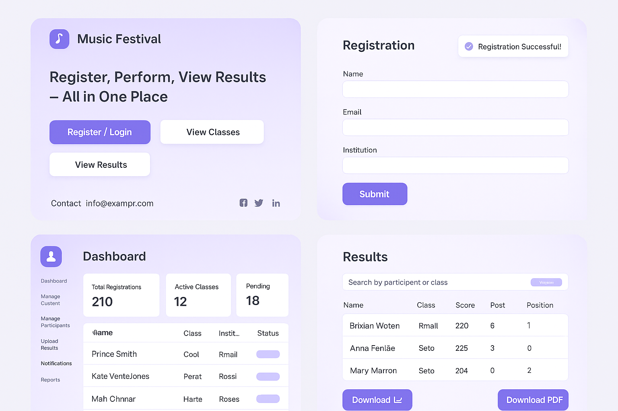

## Appendix D: Test Cases and Results

**Table 5: Test Cases and Results**

|  |  |  |  |  |  |
| --- | --- | --- | --- | --- | --- |
| **Test ID** | **Module** | **Description** | **Expected output** | **Actual output** | **Status** |
| TC001 | Login | Valid user credentials | Dashboard loads | Works correctly | Pass |
| TC002 | Register | New participant registration | Data stored | Works correctly | Pass |
| TC003 | Admin manage classes | Add/edit classes | Updated database | Works correctly | Pass |
| TC004 | Result entry | Judge submits scores | Score saved | Works correctly | pass |
| TC005 | Search result | User searches by name | Filtered results | Works correctly | pass |



## Appendix E: Hardware and Software Requirements

**Table 6: Hardware and Software Requirements**

|  |  |
| --- | --- |
| Category | Requirement |
| Hardware | Intel Core, 4GB RAM, 500GB HDD |
| Software | Windows 10, XAMPP, Visual Studio Code, Chrome |
| Database | MySQL Server (via XAMPP phpMyAdmin) |
| Language | PHP, HTML5, CSS3, JavaScript |
| Tools | Figma(for UI mockups), Draw.io (for diagrams) |



## Appendix F: User Manual Summary

1. Login/Registration: Users create accounts and log in to access the system.

2. Class Selection: Participants select the category (e.g., vocal, instrumental, group).

3. Result Management: Judges input scores, and results are auto-calculated.

4. Admin Functions: The admin manages users, judges, and performance categories.

5. Public Results: Anyone can view published results online after events.